Rotary Club of Kathmandu Mid-Town
Breakfast Chatter


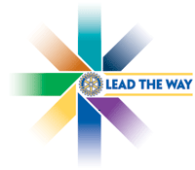
28July 2006 The Weekly Bulletin of Rotary Club of Kathmandu Mid-Town Bc # 4 of 2006-07

District : 3290 Web: www.rotarymidtown.org.np Club Id : 26776

JULY IS THE LITERACY MONTH
As countries seek to position themselves favorably in the new global economy, policymakers have realized the importance of seriously developing their country's human capital. It is essential to raise the basic education and literacy levels of all people in order to compete in today's world marketplace. This includes providing access to education for the rural poor and women, groups that have traditionally been underserved but can no longer be ignored. Basic skills training is a prime tool in development work as it improves basic education and literacy levels while at the same time addressing many local health and economic needs.
Literacy rates for women worldwide are lower than for men, and the disparity is most extreme for rural populations. Since mothers' literacy and education levels are often the key to children's attainment and health, long-range and country-wide strategies for economic progress must address women's literacy. Therefore, program developers target women and young girls in their efforts to raise literacy levels and increase the economic viability of the country in the global marketplace.

Talk Program on Higher Education in Nepal
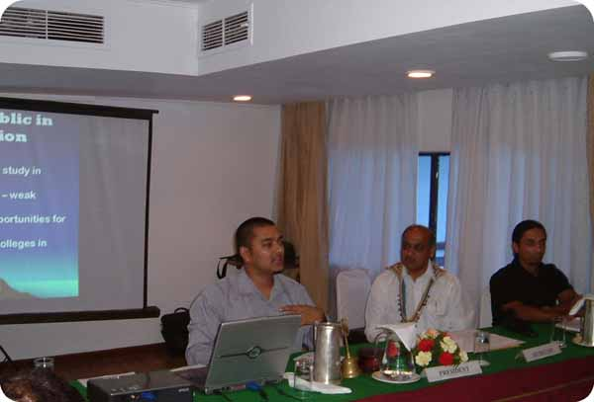
Guest Speaker Tejendra J Pherali speaking at Club meeting on 21 July Friday morning

Weekly Meetings and Programs
Date | Program/Speaker | Program/Topics of Presentation
28 July 2006 | Ms Inku Subedi | Educating disadvantaged children of Nepal
4 August 2006 | Club Assembly | Plan and programs for the year 2006-07
11 August 2006 | Bhimarjun Acharya | Making Constitution through Constituent Assembly

Friday, 28 July, morning:
Ms Inku Subedi will be talking about the possibility of promoting education in Nepal through small yet determined efforts of volunteers : the current efforts, past achievements, future goals, and challenges faced by two sister organizations - Nepalese Children’s Education Fund (NCEF) based in US and Campaign for Education (CE) in promoting education in Nepal.
Established in 2002, NCEF has raised more than $37,000 and awarded a total of 116 scholarships in Kathmandu, Kavre, Nepalgunj, Patan, and Mustang. NCEF has collaborated with its sister organization CE since 2005 in identifying disadvantaged children who are otherwise unable to receive education. These children are provided with scholarships for tuition and educational supplies until they complete high school. NCEF and CE are both organizations run entirely by volunteers.

Coverage of the 2006 RI Convention
Literacy the key to breaking cycle of poverty: keynote speaker
Copenhagen, Denmark:
After seeing the "ravages of poverty and the paralysis of illiteracy," Sister Ethel Normoyle said that when people can read and write, it helps solve a myriad of interlocking problems. Literacy's benefits can include increasing feelings of self-worth and helping people find work.
Sister Ethel, a Catholic nun and nurse, works in the slums of South Africa in the Missionvale shantytown near Port Elizabeth. In her 12 June keynote address at the Rotary International Convention, she set the tone for discussions about Rotary's role in breaking the cycle that connects poverty, disease, and illiteracy.
"There are so many factors to the human tragedy, but illiteracy in South Africa is the main factor that will most definitely lead to poverty and prevent people from getting out of it," said Sister Ethel. "Literacy is the only ticket out of poverty, as it encompasses all aspects of personal, emotional, social, and economic development," she said. The Irish-born nun has worked in South Africa since 1972 and since 1988 has focused on the 100,000 people in Missionvale, one of South Africa's most poverty-stricken areas. While working there, Sister Ethel has spent countless hours cleaning children's maggot-filled wounds, comforting the dying, and cupping a candle in a dark shack as children did their homework.
Missionvale suffers from a 90 percent unemployment rate, a soaring incidence of HIV/AIDS and other infectious diseases, and lacks sanitation. But with Sister Ethel's tireless work and community support, the Missionvale Care Center has expanded. The clinic she built now treats 170 patients a day.
The Rotary Club of Port Elizabeth West, South Africa, which has been working with Rotary clubs in Missouri, USA, has helped the center grow through a mix of programs. These include providing a powder for a nutritional soup and a Christmas gift drive for children.
Many Rotarians were visibly moved Sister Ethel's speech, which she concluded by lifting up her arms and singing a simple prayer. "Let the children have a world where there is no pain or sorrow," she sang.
Following this, RI President Carl-Wilhelm Stenhammar and his wife, Monica, praised Sister Ethel's tremendous work and presented her with a check from Rotary International for US$10,000.
Literacy should be continually emphasized. "If we have this continuity, then we can adapt literacy programs to our own communities' needs and make a difference," said Biodun Odeleye, PDG of District 9130 ( Nigeria).

Mid-Towners !
If you have any informtion on Rotary activity that you think should be interesting to other fellow Rotarians please send it for inclusion into the BC to make it more informative and interesting.
Thanks

RI President William B. Boyd has selected water as his first emphasis.
He has chosen health and hunger as his second emphasis.
His third emphasis is on literacy.
He sees literacy as "the escape hatch from the cycle of poverty" and a natural complement to his emphases on water and health and hunger.
"Literacy enables communities to take care of their water resources, address their own health and hunger issues, and teach the next generation," he says.

28 July 2006 The Weekly Bulletin of Rotary Club of Kathmandu Mid-Town Bc # 4 of 2006-07

Editor: RR Shrestha, CSD email: rryes@wlink.com.np

